Molecular Techniques Exam II
Name______________________________

FINAL EXAM - Take Home Portion: This is a take home and in-class oral interview exam. NO GROUP WORK for any of the project. I expect you to go beyond notes from class for your answers. Use the book and internet sources - reasonable sources not blog and question sites to supplement your current understanding. NO BULLET POINTS. I expect a complete answer with supporting evidence and mechanism. Declarative statements must be backed up. Simple answers, even if correct will not earn full points. ANY evidence of group work will result in a zero for this exam. ANY evidence of plagiarism will result in a zero. Reference where appropriate. Turn your final exam, TYPED when you take the in class oral examination.

FINAL EXAM In-Class Oral Portion: Each student will sign up for a 15 min interview portion of the final. I will ask questions of the following nature - Show and describe how to set up a (gel, PCR reaction, restriction digest, spin column purification), describe subcloning using topo cloning, golden gate cloning, traditional ligation or gibson cloning. PCR questions on real time PCR, site directed mutagenesis (insertion, deletion or site directed mutagenesis), strains of bacteria used in molecular biology, plasmid information. Each student will receive three total questions. If one question stumps you, you can ask for a replacement question. Your answers will be assessed based on being complete, its clarity, and correctness.

1) Describe the polymerases used for PCR. Include key features and include details of the polymerases. What are the factors that increase or decrease the error of a PCR and its fidelity? (10 pts)

2) Look at several corporate websites and identify two different PCR polymerases - what are the specific differences between each polymerase. (10 pts)

3) General PCR Questions.
- Describe the factors to design a good PCR primer for routine PCR amplification. (10 points)
- Below you see two gels. The gel on the left is shows what SHOULD have been observed after a PCR reaction. The gel on the left… was run by someone else. How would you describe the results of the bands gel on the right. Not the cause (that is next) but describe the results the smearing and multiple bands (5 pts)
- What is the likely cause(s) of the different bands and smearing? (10 points).
- Suggest several different ways to fix the PCR to get the results shown on the left instead of the gel on the right. (20 points)
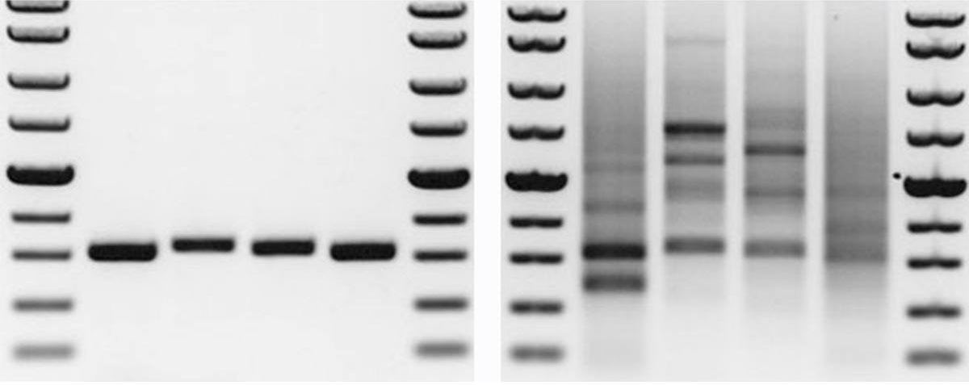

4) What is the difference between SYBER Green and Taqman rtPCR? How they work and the chemical nature of the two rtPCR components. (20 pts)

5) Can you multiplex using SYBER Green? Why or why not? How does TaqMan qPCR differ from Molecular beacon q PCR? (20 pts)

6) Define ct, melt curve and multiplexing in terms of rtPCR. (15 pts)

7) In organic chemistry class, you have created a compound to end lung cancer. You think your drug will bind transcription control of CNCR gene that codes for cancer protein1 (CP1) and not block expression of GDGENE1 gene which codes for good gene protein 1 (GGP1).
- Design and draw a rtPCR experimental result if you were to look at the expression difference between two test genes/proteins with and without your drug treatment.
- Include what you expect the actual data to look like (florescence vs cycle) and
- calculate the ΔΔct (delta delta ct) value for your experiment.
Be creative and if you’re stuck on what to do, contact your instructor. Include appropriate controls to do this experiment. You will have to look up rtPCR tutorials to determine the controls and how to do the work. Make up your ct values as appropriate... (50 pts)
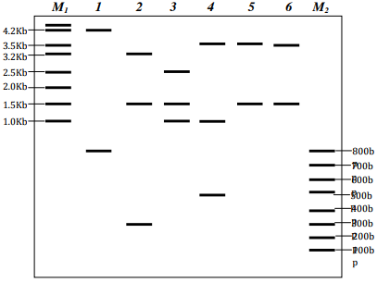
8) You are given a plasmid. In order to map this lasmid, you do a series of restriction enzyme digestions and obtain the following results on agarose gel electrophoresis (M1 and M2 are size markers):
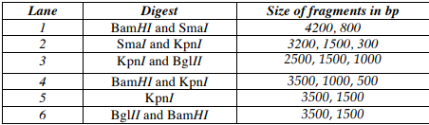

- What is the approximate size of this plasmid? (5 points)
- Create a circular plasmid map showing the relative positions of the BamH1, Sma1, Kpn1 and Bgl2 sites. Show the distances in bp between each of the adjacent sites. (20 points)

9) You have probably seen TV commercials featuring San Diego golf legend Phil Mickelson for an Amgen drug called “Enbrel®” (generically known as “etanercept”) for the treatment of rheumatoid arthritis (https://www.ispot.tv/ad/7yAn/enbrel-featuring-phil-mickelson-best-part-of-every-journey).

This protein drug binds to and inhibits the action of an inflammatory cytokine called tumor necrosis factor alpha (TNF) that is an important contributor to the inflammation and joint damage that is characteristic of this autoimmune disease. Etanercept is actually a “fusion protein” produced by molecular cloning that fuses the extracellular ligand-binding domain of the human receptor for TNF (TNFR2) at the amino terminus of the constant region of the human IgG1 antibody heavy chain. The fusion protein functions as a soluble form of what is normally a single-chain, cell-surface receptor, and has a long half-life owing to the IgG heavy chain that protects it from degradation. Enbrel is quite effective for millions of RA sufferers (and is also approved for psoriasis) and is one of the best-selling drugs in the world with global sales of more than $5 billion.

There are now a number of different fusion protein drugs on the market, but Enbrel was the prototype. It was first synthesized and shown to be highly active and unusually stable as a modality for blockade of TNF in vivo in the early 1990s by Nobel Prize Winner, Bruce Beutler, an academic researcher then at the University of Texas Southwest Medical Center, who sold the rights to its use to Immunex, a biotechnology company that was acquired by Amgen 2002.

The protein sequenced of etanercept is shown below. Suppose YOU wanted to produce it.
- Using BLAST and other tools you have learned about to retrieve relevant DNA sequences, devise a strategy to clone etanercept into pCDNA3 such that it will produce this exact sequence when transfected into mammalian cells (note that TNFR2 has a 22-aa signal peptide that is cleaved from the N-terminus by signal peptidase in mammalian cells). (20 points)
- Describe the process that you would use and show the entire nucleotide sequence of the insert and the MCS, underlining the start and stop codons, (10 points)
- Highlight the coding sequence with translation (5 points)
- as well as the locations of any primers and restriction enzymes you used (5 points)

> Etanercept Sequence
LPAQVAFTPYAPEPGSTCRLREYYDQTAQMCCSKCSPGQHAKVFCTKTSDTVCDSCEDST
YTQLWNWVPECLSCGSRCSSDQVETQACTREQNRICTCRPGWYCALSKQEGCRLCAPLRK
CRPGFGVARPGTETSDVVCKPCAPGTFSNTTSSTDICRPHQICNVVAIPGNASMDAVCTS
TSPTRSMAPGAVHLPQPVSTRSQHTQPTPEPSTAPSTSFLLPMGPSPPAEGSTGDEPKSC
DKTHTCPPCPAPELLGGPSVFLFPPKPKDTLMISRTPEVTCVVVDVSHEDPEVKFNWYVD
GVEVHNAKTKPREEQYNSTYRVVSVLTVLHQDWLNGKEYKCKVSNKALPAPIEKTISKAK
GQPREPQVYTLPPSREEMTKNQVSLTCLVKGFYPSDIAVEWESNGQPENNYKTTPPVLDS
DGSFFLYSKLTVDKSRWQQGNVFSCSVMHEALHNHYTQKSLSLSPGK

